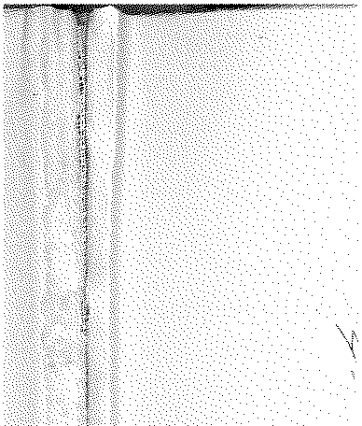

# Annual Vol ume of

TH E LAW S



# of Western N igeria

1962

## containin g

the Laws of Western Nigeria

and subsidiary legisla tion made thereunder



LOS ANGELES COUNTY

LAW LIBRARY

#### B 18

**W.N.L.N. 16 of 1962**

*The Local Government Law ( Cap. 68)*

THE CONTROL OF DRUMMING ADOPTIVE BYE-LAWS ORDER, 1957: EGBEDORE DISTRICT COUNCIL

DATE OF COMMENCEMENT: 25TH JANUARY, 1962

.:siotice is hereby given that in accordance with section 83 (3) (d) of the Local Govern­ ment Law, Cap. 681:· the Egbedore District_ _Council has resolved at its meeting held on 28th October, 1961, that its earlier resolution adopting the control of Drumming Adop­ tive Bye-laws, 1957, and published as W.R.L..N. 326 of 1957, be revoked.

Ibadan, !+th December, 1961.

**W.N.L.N. 17 of l962**

*]* . M. l!ECKLEY,

*Permanent Secretary, Jiinistry of Local Government*

#### The Chiefs Law (Cap. 19)

THE RECOGNISED CHIEI<:TAINCIES (AlVIl;cNDMENT No. 1) ORDER, 1962

DATE OF Coi,,U-WENCMENT: 25TH JANUARY, 1962

In exercise of the powers·conferied by section 3 of the Chiefs La"V, Cap.·19, upon the Minister to whom responsibility for Chieftaincy Affairs is assigned) the following Order is hereby made:-·

Citation:,

1. This Order may be cited as the Recognised Chieftaincies (Amendment No.1) Order, 1962.

Schedule to W.R.L.N. 22 of 1959



amended.

1. The Schedule to the Recognised Chieftaincies Order, 1958, is hereby amended by deleting the wo.rds '-'Olorilu of Oru!' where they occur in the list of Chieftaincies in respect Of \vhich the ljebu Northern District Council is the competent Local Government . Council and substituting therefor the words "Olor_u,of .Oru".

MADE at Ibadan this 15th day of January, 1962.

J. 0. 0MITOWOJU,

*Minister of Chieftaincy Affairs*